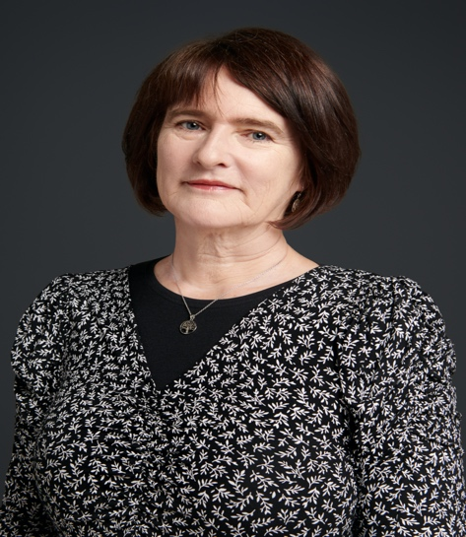

Joanne is an Associate Professor of EAP at the University of Leeds, where she’s been working in the Faculty of Engineering and Physical Sciences (EPS) since 2014. Her current role is as Year 1 Director and Director of Language for Engineering Programmes at the South-West Jiaotong University (SWJTU) – Leeds Joint School in Chengdu, China. She represents the Joint School on the Faculty Digital Education Committee and the University’s International Pathways committee and is a founder member of the Teaching and Learning Enhancement Network (TALENT) in EPS.

Joanne’s scholarship interests are in English Medium Instruction, with an ongoing study of the experience of TNE on flying faculty, and the establishment of cross-cultural teams within the partnership. She is currently working on a project with Engineering and Physical Sciences colleagues to investigate exploiting the opportunities of the TNE context to develop the soft skills of Engineering students.

