Title Calibri 16 Bold Left aligned

Name of first author Calibri 14
Department and institution Calibri 12
Name of second author Calibri 14 if applicable
Department and institution Calibri 12 if applicable

ABSTRACT

Text of abstract. Calibri 11 with 1.5 spacing. Left aligned. Not indented.

KEYWORDS: keyword 1, keyword 2, keyword 3, keyword 4, keyword 5

HEADING CALIBRI 11 BOLD CAPITALISED LEFT ALIGNED

Text. Calibri 11 with 1.5 spacing. Left aligned. Not indented. Paragraphs preceded by a line space except for the opening paragraph of a sub-section. Please note the formatting of non-integral citations as (Author, 2019) with comma or (Author 1, 2018; Author 2, 2019) with semi-colon between author names and authors in alphabetical order, and the formatting of integral citations as Author (2019) or Author (2019, p.3) for direct quotations in ‘single quotation marks’ not “double quotation marks”.

Text. Calibri 11 with 1.5 spacing. Left aligned. Not indented. Paragraphs preceded by a line space except for the opening paragraph of a sub-section. Please note the formatting of non-integral citations as (Author, 2019) with comma or (Author 1, 2018; Author 2, 2019) with semi-colon between author names and authors in alphabetical order, and the formatting of integral citations as Author (2019) or Author (2019, p.3) for direct quotations in ‘single quotation marks’.

HEADING CALIBRI 11 BOLD CAPITALISED LEFT ALIGNED

Subheading Calibri 11 bold lower case left aligned
Text. Calibri 11 with 1.5 spacing. Left aligned. Not indented. Paragraphs preceded by a line space except for the opening paragraph of a sub-section. Please note the formatting of non-integral citations as (Author, 2019) with comma or (Author 1, 2018; Author 2, 2019) with semi-colon between author names and authors in alphabetical order, and the formatting of integral citations as Author (2019) or Author (2019, p.3) for direct quotations in ‘single quotation marks’.

Text. Calibri 11 with 1.5 spacing. Left aligned. Not indented. Paragraphs preceded by a line space except for the opening paragraph of a sub-section. Please note the formatting of non-integral citations as (Author, 2019) with comma or (Author 1, 2018; Author 2, 2019) with semi-colon between author names and authors in alphabetical order, and the formatting of integral citations as Author (2019) or Author (2019, p.3) for direct quotations in ‘single quotation marks’.

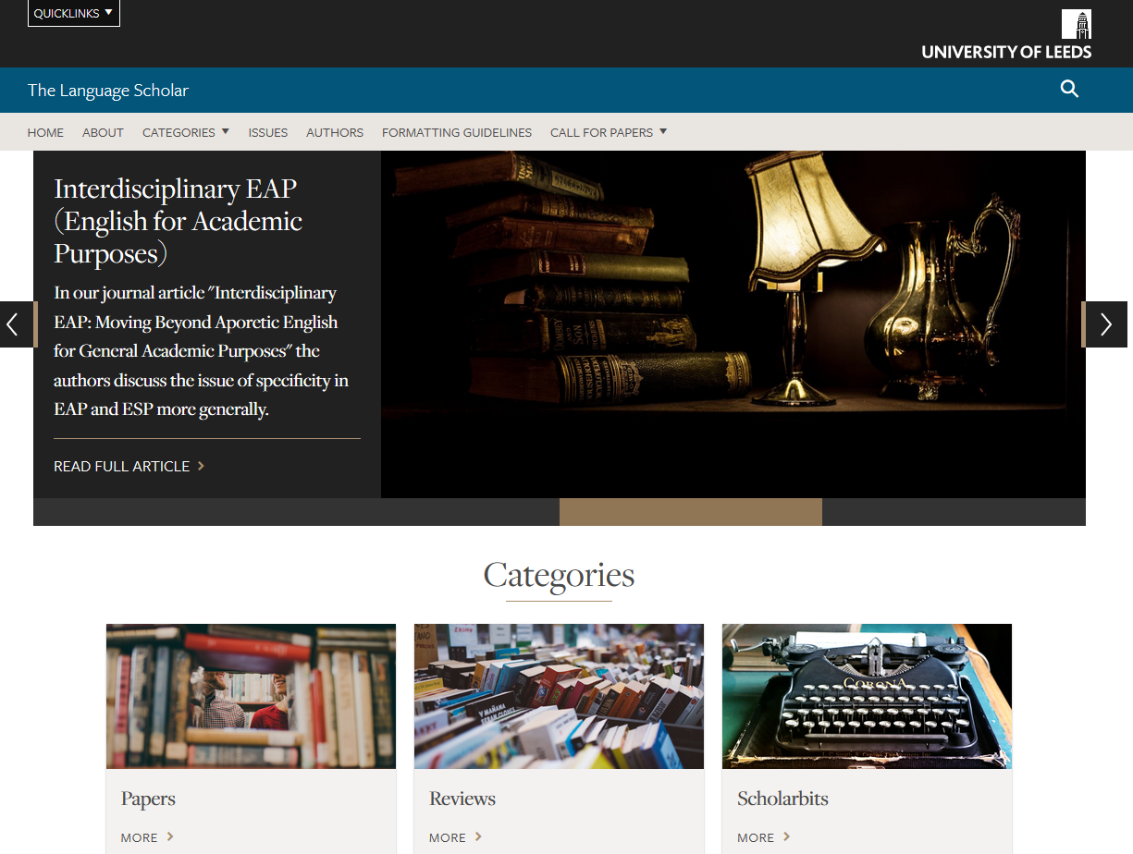
Figure 1: Title of the figure

Text. Calibri 11 with 1.5 spacing. Left aligned. Not indented. Paragraphs preceded by a line space except for the opening paragraph of a sub-section. Please note the formatting of non-integral citations as (Author, 2019) with comma or (Author 1, 2018; Author 2, 2019) with semi-colon between author names and authors in alphabetical order, and the formatting of integral citations as Author (2019) or Author (2019, p.3) for direct quotations in ‘single quotation marks’.

Header | Header
Please refer to tables and figures in the text, e.g. see Table 1. | Please refer to tables and figures in the text, e.g. see Table 1.
Please refer to tables and figures in the text, e.g. see Table 1. | Please refer to tables and figures in the text, e.g. see Table 1.
Table 1: Title of the table

Subheading Calibri 11 bold lower case left aligned
Text. Calibri 11 with 1.5 spacing. Left aligned. Not indented. Paragraphs preceded by a line space except for the opening paragraph of a sub-section. Please note the formatting of non-integral citations as (Author, 2019) with comma or (Author 1, 2018; Author 2, 2019) with semi-colon between author names and authors in alphabetical order, and the formatting of integral citations as Author (2019) or Author (2019, p.3) for direct quotations in ‘single quotation marks’.

HEADING CALIBRI 11 BOLD CAPITALISED LEFT ALIGNED

Text. Calibri 11 with 1.5 spacing. Left aligned. Not indented. Paragraphs preceded by a line space except for the opening paragraph of a sub-section. Please note the formatting of non-integral citations as (Author, 2019) with comma or (Author 1, 2018; Author 2, 2019) with semi-colon between author names and authors in alphabetical order, and the formatting of integral citations as Author (2019) or Author (2019, p.3) for direct quotations in ‘single quotation marks’.

Address for correspondence: author’s email address

REFERENCES
Please follow Leeds Harvard referencing style carefully, paying attention to capitalisation, punctuation, use of spaces, bold and italics. References Calibri 11, 1.5 spacing, with 6-point spacing after each entry, alphabetical order, left aligned, not indented. Some examples follow.
Bond, B. and Whong, M. 2017. A combined offer: collaborative development through a content-based pre-sessional programme. BALEAP Conference, 7–9 April, Bristol.
Ding, A. and Bruce, I. 2017. The English for academic purposes practitioner. Basingstoke: Palgrave Macmillan.
Greenlay, C. 2019. Developing student education practice for language teaching. The Language Scholar. 4(4), pp.8-13.
Martínez-Arboleda, A. 2013. Discovering Spanish voices abroad in a digital world. In: Beaven, A., Comas-Quinn, A. and Sawhill, B. eds. Case studies of openness in the language classroom. Dublin: Research Publishing, pp. 176-188.
University of Leeds. 2019. School of languages, cultures and societies. [Online]. [Accessed 17 May 2019]. Available from: https://ahc.leeds.ac.uk/languages

APPENDICES (IF APPLICABLE)

